KF Aerospace | Background
Delivering Results for Over 53 Years.
- Established: 1970 by Barry Lapointe in the Okanagan Valley, British Columbia, Canada
- Head Office, Flight Ops & Maintenance Facility: Kelowna, BC
- Military Aircrew Training: Portage la Prairie (Southport), Manitoba,
- Additional Operations: Hamilton, Ontario; Vancouver, BC, Calgary, Alberta and Ottawa, Ontario (coming soon)
- Workforce: 1,200+
- Key Customers: Boeing, WestJet, Air Canada, Icelandair, Lynden Cargo, Omni Air, Canadian Department of National Defence, Royal Canadian Air Force
A Canadian success story, KF Aerospace was founded as Kelowna Flightcraft in 1970 by Barry Lapointe. It has evolved into a leading aerospace company and the largest commercial Maintenance, Repair and Overhaul (MRO) provider in Canada.
KF Aerospace excels in aircraft MRO, aerospace engineering, military aircrew training, air cargo operations and aircraft leasing. Industry-recognized for its skilled workforce, KF Aerospace is dedicated to innovative, on-time and cost-effective solutions.
KF Aerospace supports corporate, commercial, and military customers globally, including major aircraft manufacturers and airlines, and provides vital training and in-service support services for the Royal Canadian Air Force (RCAF).
Learn more at kfaero.ca.

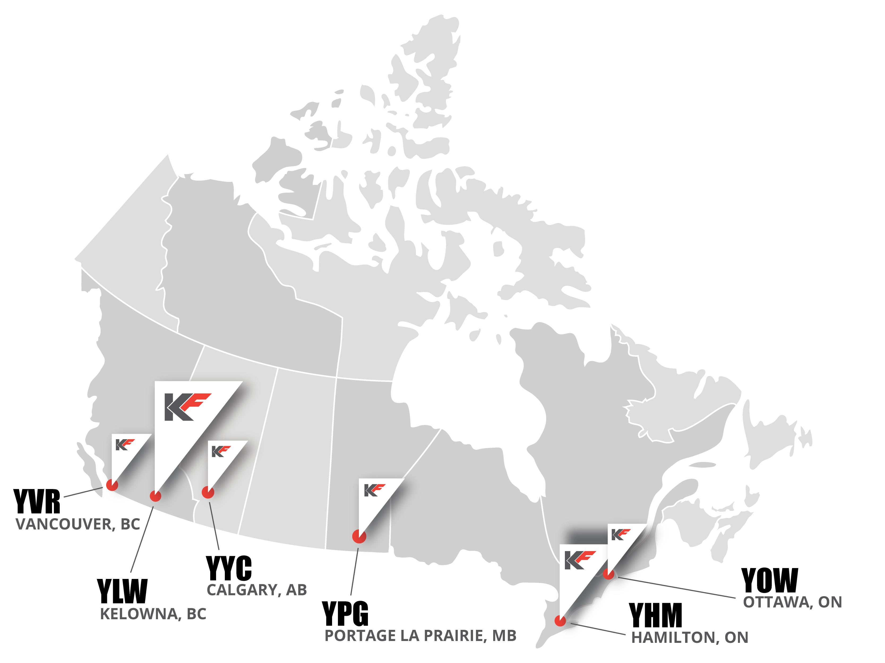
KF Aerospace | Business Divisions
KF Maintenance, Repair & Overhaul (MRO) Services
- Canada’s Largest Commercial MRO Provider
- Annual Output: Over 1,000,000 maintenance hours on 300+ projects
- Maintenance Lines: 17 across Canada (10 Kelowna, 5 Hamilton, 2 Southport)
- Maintenance Training Organization (ATO)
- Expertise Spotlight: Boeing 727, 737, 757, 767 (maintenance and modifications); Airbus A320 support, Lockheed 100-J Hercules, De Havilland Canada Dash 8-Q400 and ATR.
With major MRO facilities in Kelowna, BC, and Hamilton, ON, and additional line maintenance in Vancouver, BC, KF Aerospace is a leader in providing comprehensive MRO services. Our teams deliver modifications, parts, heavy maintenance and line maintenance solutions to Canadian and international airlines and military customers at our facilities or on-site at customer locations upon request.

Our Shops capabilities include manufacturing and repairs of landing gear, plating, component overhaul, composites repairs, Non-Destructive Testing (NDT), avionics, composites and painting.

KF Engineering
- Accreditations: Transport Canada Design Approval Organization (DAO), Department of Defence Recognized-DAO
- Certifications: Numerous Supplemental Type Certificates (STCs), repair approvals, Type Certificate for Convair Aircraft
- Specializations: Passenger-to-freighter (cargo) conversions, structural modifications, avionics
Recognized for skilled technicians and timely delivery, KF Aerospace offers a broad range of in-house aerospace engineering services. Backed by decades of experience and unmatched expertise, KF Aerospace is truly a “one-stop-shop” for our customers.
KF Defence Programs
- Experience: 35 years supporting Canada’s Department of National Defence (DND)
- Roles: Prime Contractor at CFTS Program, Southport, MB; Preferred bidder for Future Aircrew Training (FAcT) Program with SkyAlyne (starting 2024); Fixed-wing Search and Rescue (FWSAR) maintenance for DND; Member of Team Poseidon for Canadian Multi-Mission Aircraft (CMMA) project
- Limited Partnerships: Founding partner of SkyAlyne with CAE, Inc. for RCAF’s FAcT Program
Since 2005, KF Aerospace has led a group of partner contractors to provide pilot training and in-service support for the Royal Canadian Air Force (RCAF) in Southport, Manitoba. KF and its partners are responsible for managing live flying, simulation and classroom training, and all support functions including aircraft maintenance, facility maintenance and site services including lodging, meals and groundskeeping. Over 80% of RCAF pilots receive their ‘wings’ upon graduating from the CFTS Program.
KF is a founding partner of SkyAlyne (along with Canadian company CAE) to provide an innovative, made-in-Canada solution for all phases of aircrew training and in-service support for the RCAF’s Future Aircrew Training (FAcT) Program. In July 2023, SkyAlyne was named preferred bidder for the 20+ year, multi-billion-dollar contract. A formal contract award is expected in 2024.
In 2023, KF Aerospace was listed as #14 in Canadian Defence Review’s annual rankings for top Canadian defence companies.
Flight Operations/Cargo
- Experience: 50 years
- Reliability: 99% on-time dispatch
- Passenger Services: KF Aeroflyer passenger charter operator (since 2022) on B737NG aircraft.
- Cargo Services: Operations for BC air cargo network (main customer: Purolator Canada); Convair 580s (Type Certificate Holder)
- Dispatch: Type-A dispatch services for Canadian operators
KF Aerospace ensures reliable cargo operations and charter services, backed by a dedicated team and robust fleet. KF daily air cargo flights in support of the BC air cargo network.
Aircraft Leasing
- Aircraft on/available for lease: Boeing 737-800, Boeing 737-400, Boeing 737-300, ATR42 and ATR72, B727, and Convair 580/5800
- International Leasing Company: Knight Aircraft Leasing
KF Aerospace’s different aircraft types offer custom-made programs to support our customer’s cargo, passenger, and specialized operations.
KF Aerospace | Contacts
Media Inquiries/Stakeholder Relations:
Matt Stone
Engagement, Communication and Marketing Lead
m.stone@kfaero.ca
C (250) 540-9236
Primary Spokesperson:
Grant Stevens
Chief Corporate Services Officer (CCSO)
g.stevens@kfaero.ca
P (250) 491.5567
C (250) 864-4034

